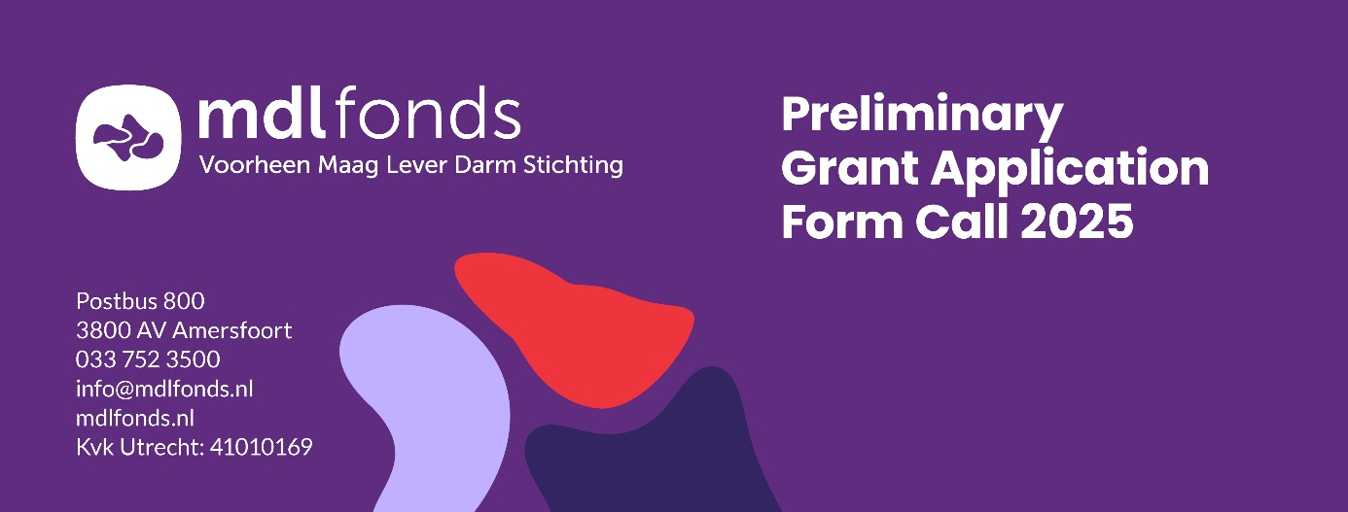

***Projectnumber: \****

*\* will be assigned by the MDL Fonds*

Please refer to the ‘Manual Preliminary Grant Application 2025’ for instructions.

**Attention**: We would like to receive some information about your application in advance. Make sure you fill in the form ([Registration Preliminary Grant Application](https://www.mlds.nl/wetenschappelijk-onderzoek/voor-onderzoekers/subsidielijn/registratie-vooraanvraag/)) before the 3rd of February 2025 at 12:00 (noon).

# General information

|  |  |  |  |  |  |
| --- | --- | --- | --- | --- | --- |
| **1** | **Title of the Project** |  | | | |
| **Dutch summary** (max. 200 words) |  | | | |
| **2** | **Institute** |  | | | |
| **Department** |  | | | |
| **Address** |  | | | |
| **3** | **Project Leader** | First name, last name and title(s); Mr./ Mrs./ Other ……………………………………………………………………………………….  Please specify your position at the apply institute: ……………………………………………………………………………………….  Do you have a permanent position? If not, when does your contract ends? .............................................................................................................. | | | |
| **Telephone** |  | | | |
| **E-mail** |  | | | |
| **2nd Project Leader** (if applicable) | First name, last name and title(s); Mr./ Mrs./ Other ……………………………………………………………………………………….  Please specify your position at the apply institute: ……………………………………………………………………………………….  Do you have a permanent position? If not, when does your contract ends? .............................................................................................................. | | | |
| **Telephone** |  | | | |
| **E-mail** |  | | | |
| **4** | **Career Development Grant**  (if applicable) | Not applicable- Master’s (“doctoraal”)  ………………………………………………………………………………………………………………….  - PhD  ………………………………………………………………………………………………………………….  - Work experience since graduating  ………………………………………………………………………………………………………………….  - Brief summary of research over the last five years  ………………………………………………………………………………………………………………….  - International activities  ………………………………………………………………………………………………………………….  - Other academic activities  ………………………………………………………………………………………………………………….  - Scholarships, grants and prizes  ………………………………………………………………………………………………………………….  - Publications International (refereed) journals National (refereed) journals Books, Contribution to books, Other:  ………………………………………………………………………………………………………………….  - Describe your motivation for this research and what you hope to achieve in the next 5 to 10 years (max 200 words)  …………………………………………………………………………………………………………………. | | | |
| **5** | **Project group** | |  |  |  |  | | --- | --- | --- | --- | | Name, academic title | Discipline | Employed by | Time spent on this project (% fte) | |  |  |  |  | |  |  |  |  | |  |  |  |  | |  |  |  |  | |  |  |  |  | |  |  |  |  | |  |  |  |  | | | | |
| **6** | **Type of research** | Clinical  Translational | | | |
| **Theme of research** | **GI Oncology**  Oesophageal cancer  Colon cancer  Liver cancer (HCC) | **Chronic GI disease/disorder**  IBD  Coeliac disease  Chronic pancreatitis  IBS/intestinal complaints | | **Acute GI disease**  Acute pancreatitis  NEC  Portal hypertension  Hepatitis  Cholecystitis |
| **Follow-up research** | Is the research further development and/or implementation of promising project results, from research already funded by the MLDS? Please indicate the previous project code: …………………………………………………………… | | | |
| **Duration of research** |  | | | |
| **7** | **Budget** | | | | |
| **Personnel costs** | |  |  |  |  | | --- | --- | --- | --- | | **Type** | **FTE** | **Duration of appointment** | **€** | | PhD student (non-MD) |  |  | € | | PhD student (MD) |  |  | € | | Post doc |  |  | € | | Supporting Non Academic personnel |  |  | € | | Other, … |  |  | € | | **Total personnel costs** | | | **€** | | | | |
| **Equipment costs** | |  |  |  | | --- | --- | --- | | **Type** | **Specification** | **€** | | Materials |  | € | | Animals |  | € | | Other, … |  | € | | **Total Equipment costs** | | **€** | | | | |
| **Total project costs** | € | | | |
| Amount covered by grant MDL Fonds | € | | | |
| Amount covered by others | Amount: €  Name of organization: Amount: €  Name of organization: | | | |
| Amount requested by others | Has this grant proposal been submitted or will this proposal be submitted to another funding organization?  No  Yes, namely to………………………………for an amount of €………………………… Decision expected in: ………………………………….. (mm/yyyy) | | | |
| **8** | **Signatures** | | | | |
| **Project leader** Date (dd/mm/yyyy) | | | | |
| Name:  Signature: | | | | |
| **2nd Project leader** (if applicable) Date (dd/mm/yyyy) | | | | |
| Name:  Signature: | | | | |
| **Participants of project group** | | | | |
| Name:  Signature: | | | Name:  Signature: | |
| Name:  Signature: | | | Name:  Signature: | |
| Name:  Signature: | | | Name:  Signature: | |
| Name:  Signature: | | | Name:  Signature: | |
| **Head of department/ institute** Date (dd/mm/yyyy) | | | | |
| Name:  Function:  Signature: | | | | |

# Project summary (English, max 1300 words)

*Do not exceed the maximum of 1300 words excluding five relevant publications.*

|  |  |  |
| --- | --- | --- |
| **9** | **Title** | English:  Dutch: |
| **10** | **Background** |  |
| **11** | **Hypothesis** |  |
| **12** | **Objective** |  |
| **13** | **Relevance** (for the patients/end users) |  |
| **14** | **Patient participation** (during design and execution of the project) |  |
| **15** | **Methods** | |
| Study design |  |
| Study population | Inclusion criteria:  Exclusion criteria:  Sample size calculation:  Recruitment strategy: |
| Samples (if applicable) | Origin:  Type:  Amount:  Availability:  Feasibility of the envisaged research sample: |
| Analysis | Study parameters/endpoints:  Methods/intervention:  Machine/software:  Expected outcomes: |
| Work plan including timeframe and milestones |  |
| **16** | **Anticipated results** |  |
| **17** | **Five relevant publications concerning this application** | 1)  2)  3)  4)  5) |

# Appendix A. International experts

|  |  |  |  |
| --- | --- | --- | --- |
| **A.** | **List five international experts that should be able to review your project, without a Conflict of Interest** | Name |  |
| Institute |  |
| Specialties |  |
| E-mail |  |
| Name |  |
| Institute |  |
| Specialties |  |
| E-mail |  |
| Name |  |
| Institute |  |
| Specialties |  |
| E-mail |  |
| **Name** |  |
| Institute |  |
| Specialties |  |
| E-mail |  |
| **Name** |  |
| Institute |  |
| Specialties |  |
| E-mail |  |